1. create database exp3;

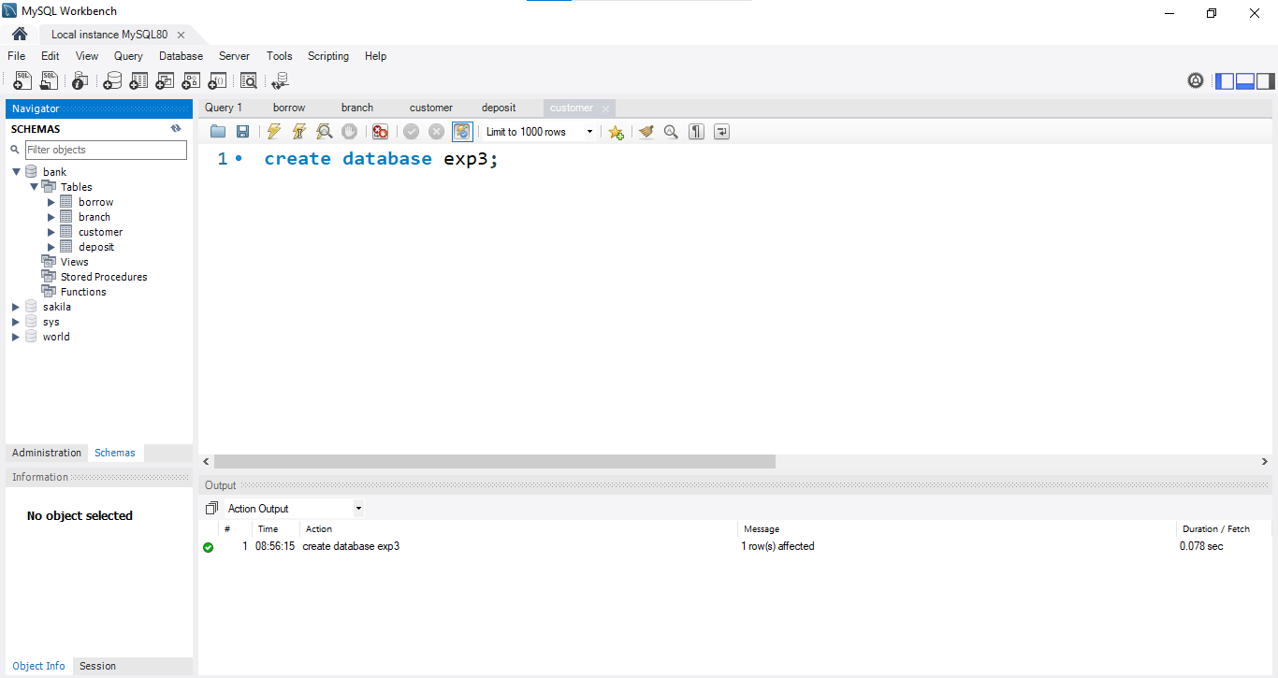

1. use exp3;

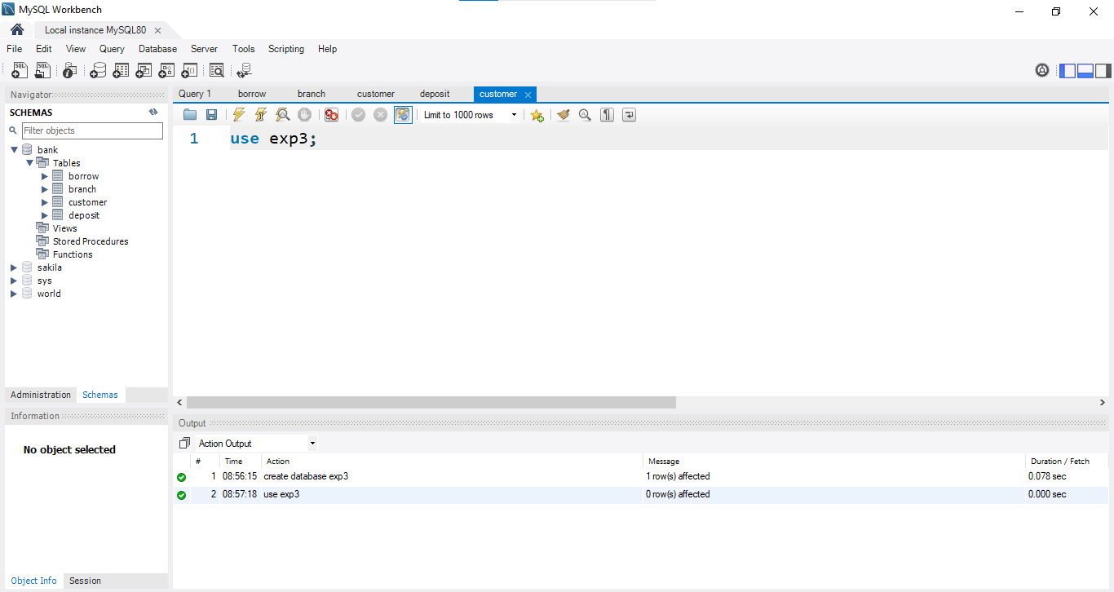

1. create table emp (eno int primary key, ename varchar(20), ehiredate date, esalary int, ecomission int, check (length(eno)>=3), check (esalary<=5000));

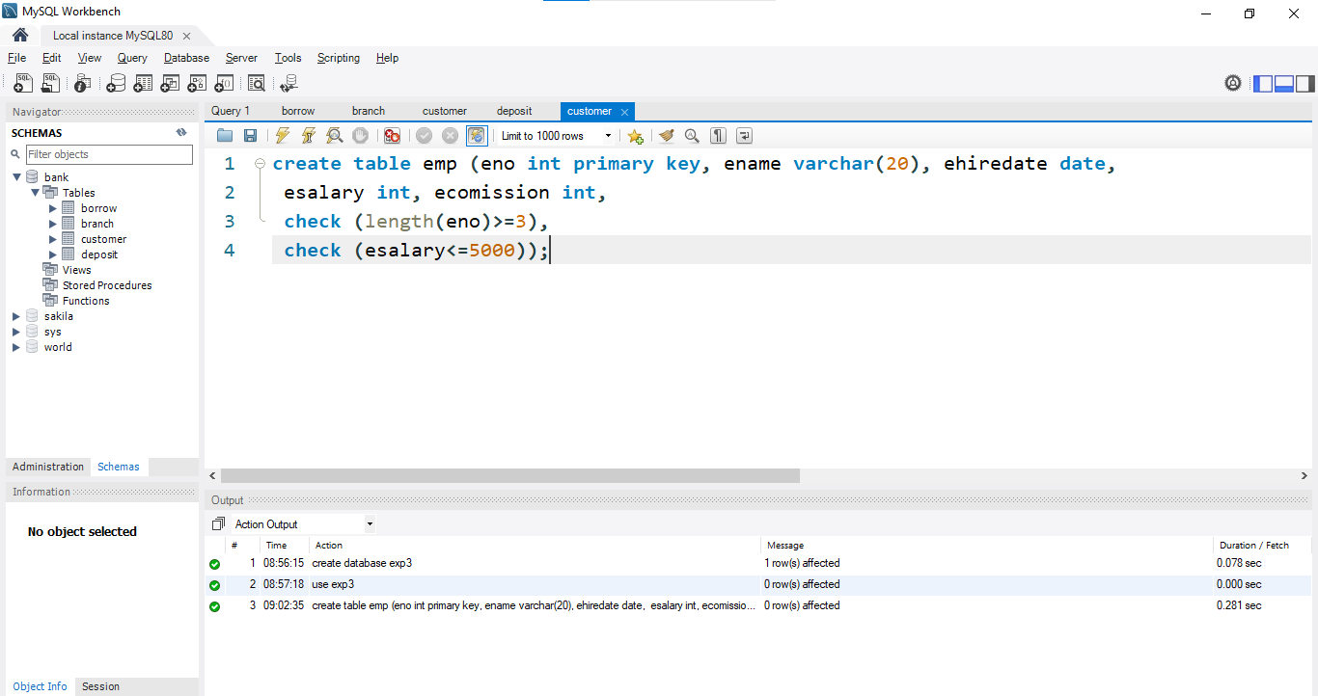

1. insert into emp (eno, ename, ehiredate, esalary) values (101, 'Ramesh', '07-01-1980', 5000);

insert into emp (eno, ename, ehiredate, esalary, ecomission) values (102, 'Ajay', '05-07-1985', 5000, 500);

insert into emp (eno, ename, ehiredate, esalary) values (103, 'Ravi', '12-08-1981', 1500);

insert into emp (eno, ename, ehiredate, esalary, ecomission) values (104, 'Nikesh', '03-03-1983', 3000, 700);

insert into emp (eno, ename, ehiredate, esalary) values (105, 'Ravi', '05-07-1985', 3000);

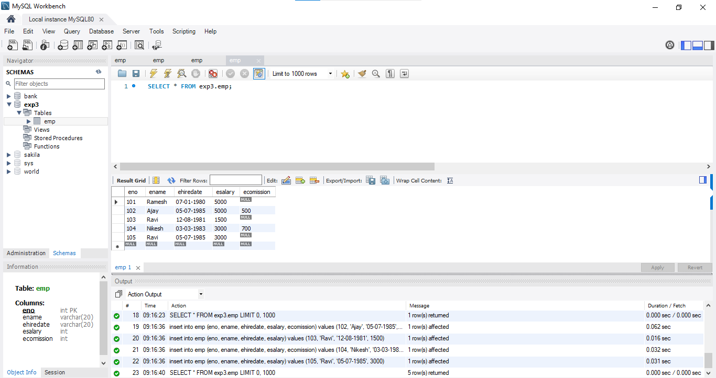

1. Add

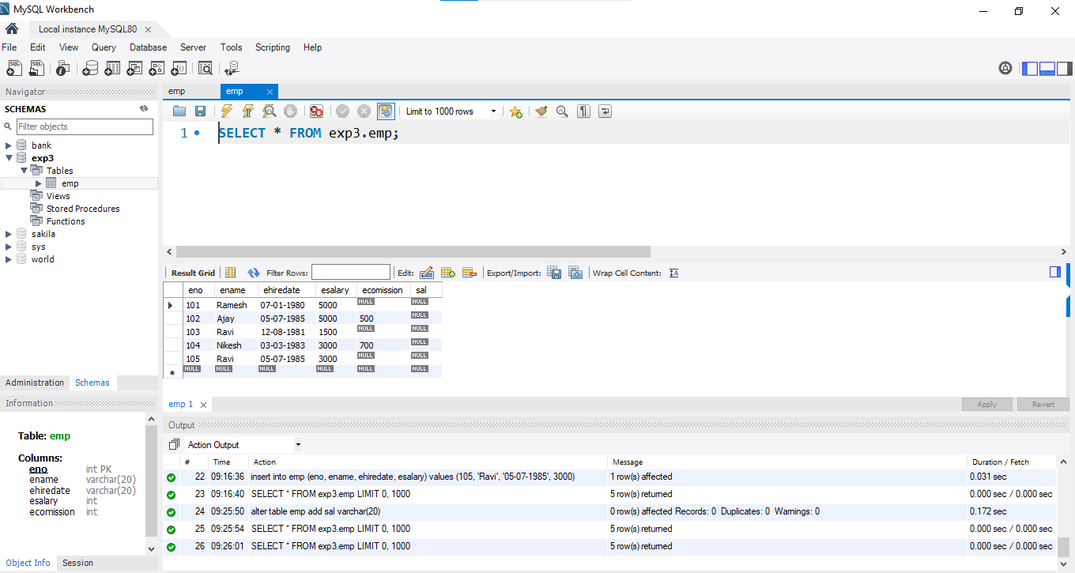

1. alter table emp drop sal

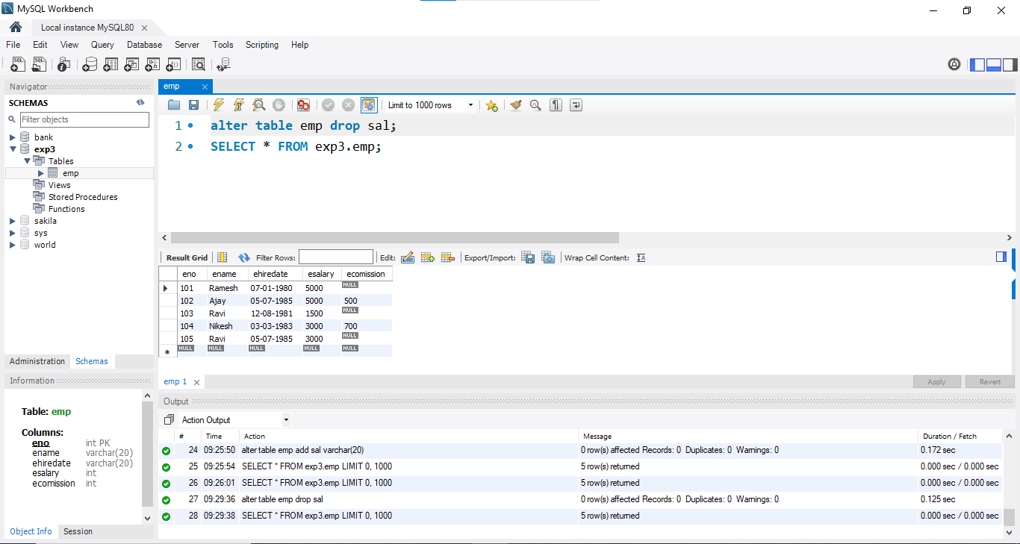

1. ALTER TABLE emp RENAME COLUMN ename to name;

SELECT * FROM emp;

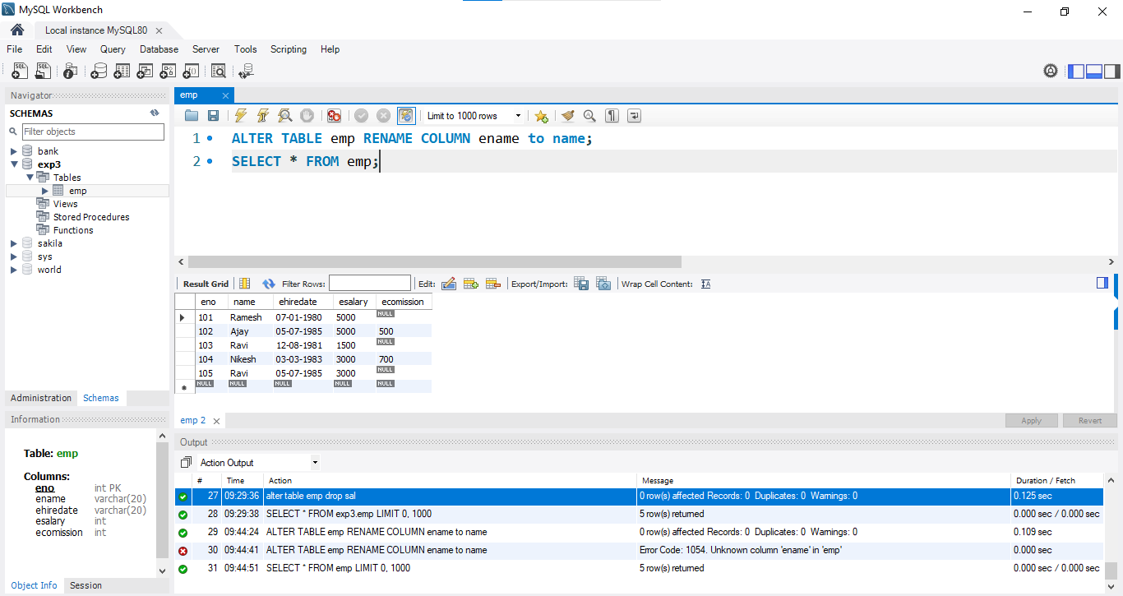

1. Alter table emp rename to emp_details;

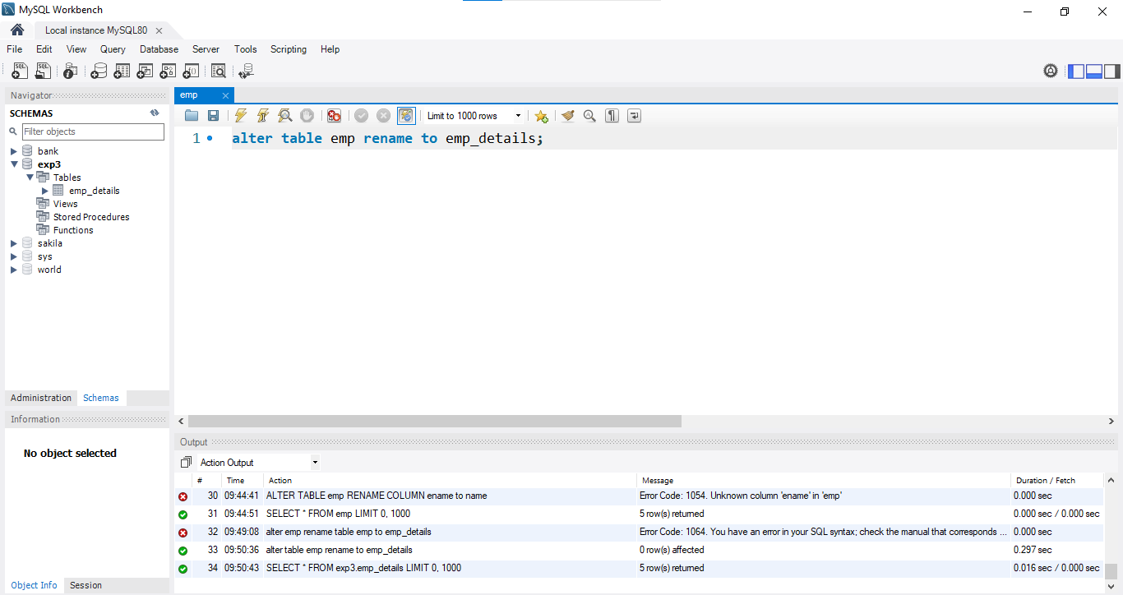

1. truncate emp_details;

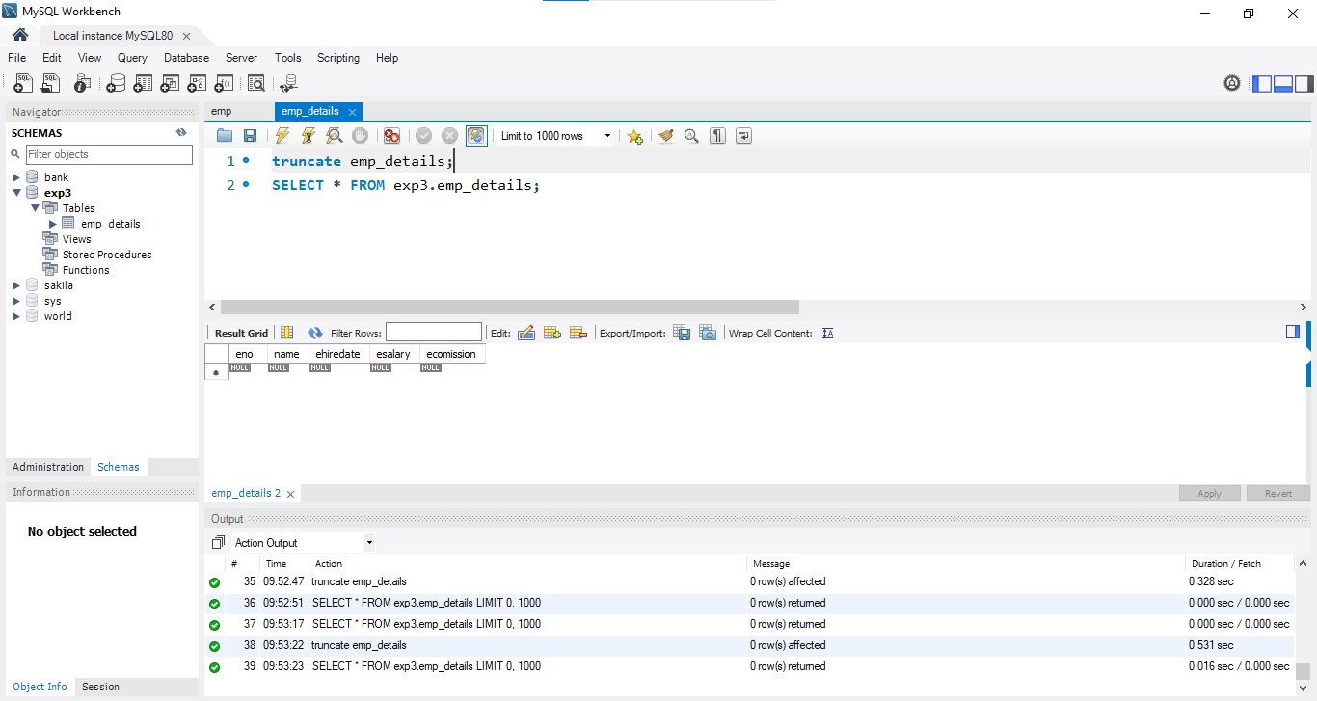

1. drop table emp_details;

